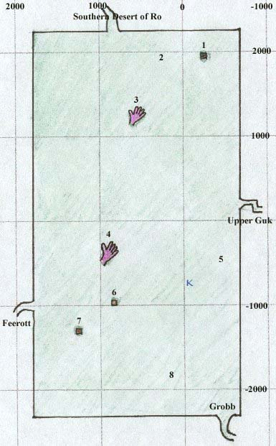

* 1. Tower, Home of [Jojongua](https://wiki.project1999.com/Jojongua" \o "Jojongua) and Fetid Froglok Ghouls
* 2. High level monsters (froglok foragers and kobold hunters)
* 3. Stone Hand where shaman spell vendor [Stragak](https://wiki.project1999.com/Stragak" \o "Stragak) is located
* 4. Stone Hand with shadowmen (-430, 980)
* 5. Froglok Hunting Grounds
* 6. Ruined Ferry
* 7. Submerged Hut
* 8. Newbie Area

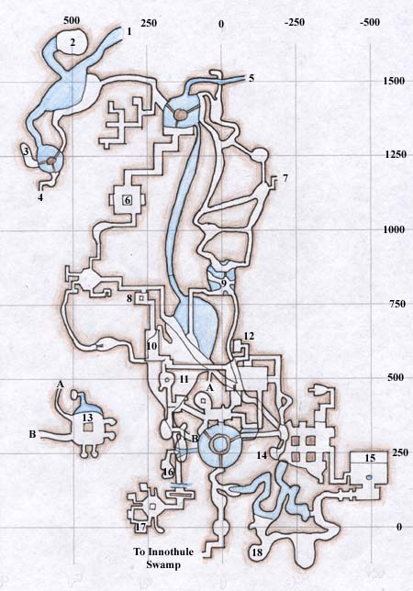

**Upper Guk**

1. Zoneline to Lower Guk, Dead Side

2. Croc Room with Ancient Crocodile who drops Gatorscale Leggings and Gatorscale Sleeves (PH is a saltwater croc, between one and five)

3. Room with a froglok nokta shaman who drops Globe of Shadow, placeholder Vis Shaman

4. Zoneline to Lower Guk, Live Side

5. Zoneline to Lower Guk, Dead Side

6. Room with A Froglok Summoner, A Froglok Priest, drops Golden Rod used for Enchanter quest (Rod of Insidious Glamour), and A Froglok Shin Knight

7. Zoneline to Lower Guk, Dead Side

8. Ladder down Pit

9. The Pits with Heart Spiders, Secret Room in Water to Dark Elf named Tempus and Skeletal Monk who drops Glowing Mask

10. Ramp Room with a froglok gaz squire who drops Collar of Undead Protection (common) and Runed Bone Fork (rare)

11. Mushroom Farm with Fungus Men, also A Fungus Mutant who drops Guk Bracket Mildew (common) and Degenerated Guk Weed (rare)

12. Room with a froglok idealist, who drops Vial of Egg Whites (common) and Moss Mask (rare), and A Froglok Tonta Knight, who drops Soiled Boots (common)

13. Room with the froglok warden who drops Elf-Hide Gloves (common) and Troll-Hide Belt (rare), room to north is safe underwater cove

14. Room with a froglok realist who drops Pouch of Ghoul Ash (common) and Reed Ring (rare)

15. Temple with a froglok scryer who drops Bracelet of Woven Grass (common) and A Shimmering Orb (rare), also Glowing Mask

16. Room with a froglok necromancer

17. Barracks with the froglok shin lord who drops Silver-Plated Bracer (common) and Ghoulbane (rare)

18. Heart Spider Room with a giant heart spider who drops Chitin Shell Shield (common) and Chitin Shell Armor (rare)